Flash Basics
Goal
Build a CNC Monitoring Web Dashboard using Flask that shows:
- Real-time machine states (Running / Idle / Alarm / Off)
- Key KPIs (Operating Time, OEE, Utilization)
- Graphs (Energy trend, Program duration, Spindle load, etc.)
Create a Dashboard :
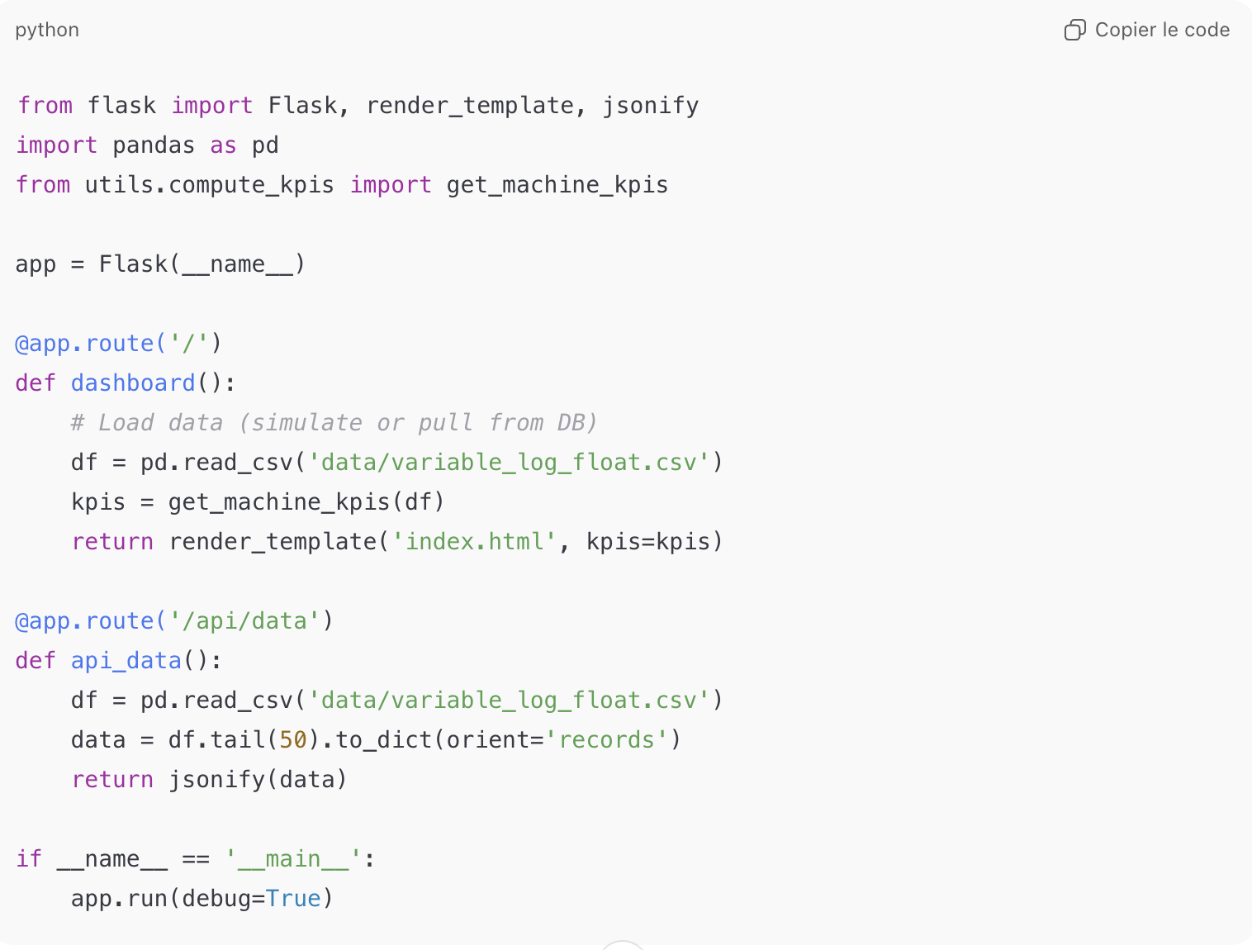
from flask import Flask, render_template, jsonify
import pandas as pd
from utils.compute_kpis import get_machine_kpis

app = Flask(__name__)

@app.route('/')
def dashboard():
# Load data (simulate or pull from DB)
df = pd.read_csv('data/variable_log_float.csv')
kpis = get_machine_kpis(df)
return render_template('index.html', kpis=kpis)

@app.route('/api/data')
def api_data():
df = pd.read_csv('data/variable_log_float.csv')
data = df.tail(50).to_dict(orient='records')
return jsonify(data)

if __name__ == '__main__':
app.run(debug=True)

Compute and return KPIs to display on the page :

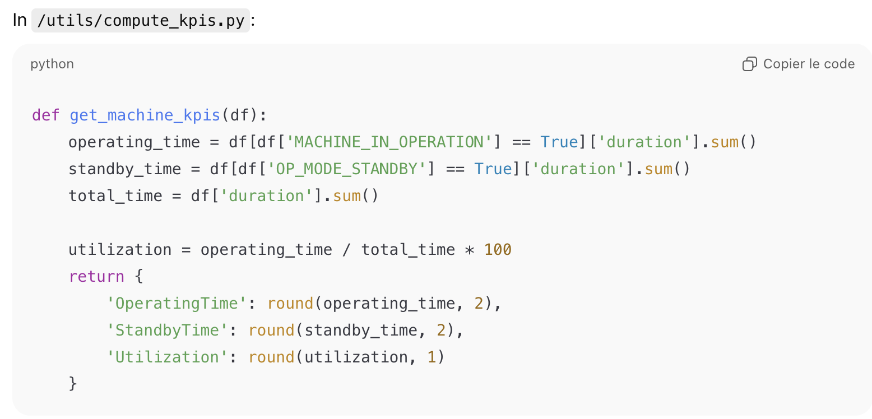
def get_machine_kpis(df):
operating_time = df[df['MACHINE_IN_OPERATION'] == True]['duration'].sum()
standby_time = df[df['OP_MODE_STANDBY'] == True]['duration'].sum()
total_time = df['duration'].sum()

utilization = operating_time / total_time * 100
return {
'OperatingTime': round(operating_time, 2),
'StandbyTime': round(standby_time, 2),
'Utilization': round(utilization, 1)
}

